GUECO- FINALS TASK 2

TASK 1:

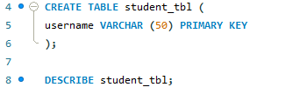

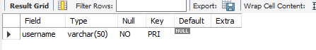

TASK2:

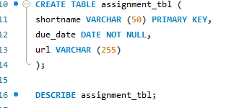

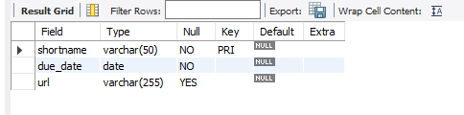

TASK 3:

